UNIVERSITY OF VISVESVARAYA COLLEGE OF ENGINEERING
(First State Autonomous University on IIT Model)
K.R. Circle, Bangalore-560001



Department of Computer Science and Engineering

Mini Project Report on

“Synaptic - Adaptive Learning Platform”

Submitted by
Charan Teja S (U25UV23T006016)
Sanjay V Guladakoppa (U25UV23T006047)
Sujeth A S (U25UV23T006052)
6th Sem, B. Tech (AIML)

Under the Guidance of
Dr. Champa H N
Professor
Department of Computer Science and Engineering
UVCE

April - 2026

University Of Visvesvaraya College of Engineering
(First State Autonomous University on IIT Model)
K.R. Circle, Bangalore-560001

Department of Computer Science and Engineering

CERTIFICATE

This is to certify that Mr. Charan Teja S (U25UV23T006016), Mr. Sanjay V Guladakoppa (U25UV23T006047), Mr. Sujeth A S (U25UV23T006052) 6th Sem, B. Tech (AIML), have successfully completed Mini-Project work entitled “Synaptic – Adaptive Learning Platform”, prescribed by the University of Visvesvaraya College of Engineering for the academic year 2026.

Dr. Champa H N Dr. S H Manjula
Professor, Chairperson & Professor
Department Of CSE, Department Of CSE,
UVCE, Bengaluru UVCE, Bengaluru

……………………………… ……………………………
Examiner 1 Examiner 2

ACKNOWLEDGEMENT

We are deeply grateful to the University of Visvesvaraya College of Engineering for providing us with the opportunity and resources to undertake this project.
We would like to thank Dr. Subhashish Tripathy, Director, UVCE, for providing us with all the facilities to work on this project. I am indebted to him for being my pillar of strength and inspiration.
We are thankful to Dr. S H Manjula, Chairperson, Department of Computer Science and Engineering, for her co-operation and encouragement at all stages of our work.
We sincerely express our gratitude to our professor, Dr. Champa H N, Professor, Department of CSE, UVCE, for her invaluable guidance, encouragement, and constant support throughout this project, expertise and constructive feedback greatly contributed to the successful completion of project.
We also extend our sincere thanks to our parents, non-teaching staff, well-wishers, and dear classmates for their support, encouragement, and kind cooperation.

Charan Teja S (U25UV23T006016)
Sanjay V Guladakoppa (U25UV23T006047)
Sujeth A S (U25UV23T006052)

ABSTRACT

The rapid advancement of Artificial Intelligence (AI) and related technologies has created a growing demand for effective and structured learning platforms. However, many existing e-learning systems rely heavily on passive content delivery and lack interactivity, real-time feedback, and proper progress tracking. This often leads to reduced engagement and difficulty in understanding complex technical concepts. To address these challenges, the Synaptic - Adaptive Learning Platform is developed as a web-based application that provides a structured, interactive, and user-friendly environment for learning concepts.
The platform is designed to guide users through a well-organized learning path that is divided into multiple phases, ranging from basic computer fundamentals to advanced topics such as Machine Learning and Deep Learning. Each phase contains clearly defined topics that are presented in a logical sequence, enabling learners to build a strong conceptual foundation. The system emphasizes active learning by integrating quizzes after each topic, allowing users to test their understanding immediately.
One of the key features of the platform is its real-time feedback mechanism. When users attempt quizzes, the system evaluates their responses instantly and provides detailed feedback, including correct answers and explanations. This helps learners identify their mistakes and improve their knowledge effectively. Additionally, the platform includes a dashboard that tracks user progress, displays completed topics, and highlights pending tasks, thereby motivating users to maintain consistency in their learning process.
The system is implemented using modern web technologies, with a responsive frontend developed using React.js and a robust backend that manages data processing, user authentication, and progress tracking. The modular design ensures scalability, allowing new topics and features to be added in the future without significant modifications.
Overall, the Synaptic platform aims to bridge the gap between traditional learning methods and modern interactive systems by combining structured content, real-time evaluation, and user engagement features. It serves as an efficient tool for students and beginners who wish to develop a strong understanding in a systematic and engaging manner.

TABLE OF CONTENTS

Title Page No.
- Introduction 04
- Literature Review 07
- Hardware & Software Requirements 09
- Proposed System Design 11
- Implementation 14
- Results 16
- Conclusion & Future Enhancements 17
- Bibliography 18

INTRODUCTION
1.1 Introduction
The rapid growth of Artificial Intelligence (AI) and related technologies has significantly increased the demand for accessible and structured learning platforms. Traditional educational approaches often fail to provide interactive and personalized learning experiences, especially in technical domains such as AI, Machine Learning, and Data Science. Learners frequently struggle with unorganized resources, lack of practical engagement, and absence of continuous evaluation.
To address these challenges, the Synaptic – Adaptive Learning Platform is designed as a web-based system that provides a structured roadmap for learning AI concepts. The platform integrates theoretical learning with interactive quizzes, progress tracking, and a user-friendly interface to ensure an engaging and effective learning experience.
The system divides the learning journey into multiple phases, starting from basic computer fundamentals to advanced AI concepts such as Deep Learning and Modern AI Systems. Each phase consists of well-defined topics and includes evaluation mechanisms to reinforce learning.

1.2 Motivation
The motivation behind developing this platform arises from the following challenges:
- Lack of structured learning paths: Many online resources are scattered and do not follow a logical progression.
- Low engagement: Traditional platforms rely heavily on passive content consumption.
- Absence of real-time feedback: Learners do not receive immediate insights into their performance.
- Difficulty in tracking progress: Users often lose motivation due to lack of measurable outcomes.
This project aims to solve these problems by providing:
- A phase-wise structured curriculum
- Interactive quizzes for active learning
- Instant feedback mechanisms
- Progress tracking and streak systems for motivation

1.3 Contributions
The key contributions of this project include:
- Development of a modular AI learning platform with clearly defined phases
- Implementation of an interactive quiz system with real-time feedback
- Design of a user-centric dashboard for tracking learning progress
- Creation of a scalable architecture that allows easy addition of new topics
- Integration of gamification elements such as streak tracking and progress indicators

LITERATURE REVIEW

The evolution of online learning systems has significantly transformed the way knowledge is delivered and consumed. Traditional classroom-based education has gradually been supplemented, and in some cases replaced, by digital learning platforms that offer flexibility and accessibility. Early e-learning systems primarily focused on delivering static content such as video lectures, PDF notes, and recorded sessions. While these platforms made education more accessible, they often lacked interactivity and failed to actively engage learners. As a result, students frequently experienced reduced motivation and lower retention of concepts.

Learning Management Systems (LMS) such as Moodle and Blackboard introduced a more structured approach to digital education. These systems enabled instructors to organize courses, track assignments, and manage assessments. Although LMS platforms improved administrative efficiency and content organization, they still relied heavily on passive learning. The lack of continuous engagement and real-time feedback limited their effectiveness in promoting deep understanding, particularly in technical subjects like Artificial Intelligence.

With advancements in educational technology, modern platforms began incorporating interactive elements such as quizzes, coding exercises, and gamification techniques. Research indicates that active learning strategies, especially those involving frequent testing and feedback, significantly enhance knowledge retention. Quizzes encourage learners to recall information actively, while instant feedback helps them identify and correct mistakes immediately. Gamification elements such as streaks, progress bars, and rewards further increase user engagement by introducing a sense of achievement and competition.

More recently, AI-driven learning systems have emerged, offering personalized learning experiences. These systems analyze user behavior and performance to adapt content dynamically. While such systems provide highly effective learning pathways, they are often complex to design and require substantial computational resources. Additionally, many of these platforms are not beginner-friendly and may overwhelm users who are new to AI concepts.
A critical analysis of existing systems reveals a gap between simplicity and effectiveness. Many platforms either offer structured content without interactivity or provide advanced features that are difficult to use. There is a need for a system that balances structured learning, interactivity, and ease of use. The Synaptic AI Learning Platform is designed to address this gap by integrating a phase-wise curriculum with interactive quizzes and real-time progress tracking. It combines the strengths of traditional LMS systems and modern interactive platforms while maintaining simplicity and scalability.

HARDWARE AND SOFTWARE REQUIREMENTS

To successfully implement and run this project, a combination of software tools and hardware resources are required. The following requirements ensure smooth functioning of the system.

3.1 Hardware Requirements
The Synaptic AI Learning Platform is designed to operate efficiently on standard computing systems without requiring high-end hardware. This ensures accessibility for a wide range of users, including students and beginners.
The hardware requirements for the system are as follows:
- Processor: Intel Core i3 or equivalent (Intel i5 or higher recommended for better performance)
- RAM: Minimum 4 GB (8 GB recommended for smooth multitasking)
- Storage: At least 10 GB of free disk space
- Display: Standard monitor with a resolution of 1366 × 768 or higher
- Input Devices: Keyboard and mouse or touchpad
- Internet Connectivity: Stable broadband internet connection for accessing the web application
These specifications are sufficient to ensure that the platform runs smoothly, supports interactive features, and provides a seamless user experience.

3.2 Software Requirements
The development and execution of the Synaptic platform rely on modern software technologies and tools. These components are selected to ensure scalability, performance, and ease of development.
The software requirements are categorized as follows:
Operating System
- Windows 10/11
- Linux (Ubuntu or similar distributions)
- macOS

Frontend Technologies
- React.js: Used for building dynamic and responsive user interfaces
- HTML5: For structuring web pages
- CSS3 / Tailwind CSS: For styling and layout design
- JavaScript: For implementing interactive functionality

Backend Technologies
- Node.js / Django: For handling server-side logic and application processing
- REST APIs: For communication between frontend and backend

Database
- Currently, structured JSON files are used for managing content. A relational database such as SQLite is proposed for future implementation.

Development Tools
- Visual Studio Code (Code Editor)
- Git (Version Control System)
- Postman (API testing tool)

Web Browsers
- Google Chrome
- Microsoft Edge
- Mozilla Firefox

PROPOSED SYSTEM DESIGN

The proposed system, Synaptic – Adaptive Learning Platform, is designed to provide a structured, interactive, and scalable environment for learning Artificial Intelligence concepts. The system follows a modular and layered architecture to ensure flexibility, maintainability, and efficient performance.

4.1 Design Objectives
The primary objectives considered while designing the system are:
- To provide a structured learning path from basic to advanced AI topics
- To ensure interactive learning through quizzes and feedback
- To enable real-time progress tracking
- To design a user-friendly and intuitive interface
- To maintain scalability for adding future modules and features

4.2 System Architecture
The system is designed using a three-tier architecture. However, the current implementation primarily focuses on the presentation layer and content structuring, while backend and data layers are planned for future development, which separates responsibilities into different layers:
1. Presentation Layer (Frontend)
The presentation layer is responsible for user interaction and visual representation of the system.
- Built using React.js for dynamic UI rendering
- Displays dashboard, learning modules, quizzes, and results
- Provides smooth navigation between different sections
- Ensures responsiveness across devices
- Implements a dark-themed interface for better readability
This layer plays a crucial role in enhancing user experience by making the platform visually appealing and easy to use.
2. Application Layer (Backend)
The application layer handles the core functionality and business logic of the system.
- Manages user authentication and session handling
- Processes requests from the frontend
- Implements quiz evaluation logic
- Generates real-time feedback for users
- Updates user progress and performance data
This layer acts as a bridge between the frontend and database, ensuring that all operations are performed efficiently and securely.
3. Data Layer (Database)
The data layer is responsible for storing and managing all system data.
- Stores user information and login credentials
- Maintains learning content and topic details
- Saves quiz questions, answers, and results
- Tracks user progress and completion status
The database ensures data consistency and allows quick retrieval of information when required.

4.3 Module Design
The system is divided into multiple modules, each handling a specific functionality.
1. User Authentication Module
- User authentication is part of the proposed system design and is not fully implemented in the current version
- Ensures secure access to user-specific data
- Maintains session management
2. Dashboard Module
- Displays an overview of user progress
- Shows:
  - Skills mastered
  - Active learning topics
  - Pending reviews
- Provides quick navigation to learning modules
This module helps users stay informed about their learning journey.

3. Learning Module
- Organized into phases and topics
- Each phase represents a level of learning:
  - Basics → Intermediate → Advanced
- Provides structured content for each topic
- Tracks completion status
This module ensures a logical progression of knowledge.
4. Quiz and Evaluation Module
- Presents multiple-choice questions after each topic
- Evaluation is handled at the frontend level using predefined JSON-based question sets
- Displays:
  - Correct answers
  - Incorrect responses
  - Explanations
This module reinforces learning through active recall and feedback.
5. Progress Tracking Module
- The system is designed to support user performance tracking; in the current version, progression is managed at the interface level
- Updates completion percentage
- Maintains learning streaks
- Displays progress visually on dashboard
This helps in motivating users and maintaining consistency.

IMPLEMENTATION

The implementation of the Synaptic – Adaptive Learning Platform is divided into two main parts: Frontend Implementation and Backend Implementation. Each part is responsible for specific functionalities that together ensure smooth system operation.

5.1 Frontend Implementation
The frontend is responsible for user interaction and visual representation of the system. It is developed using modern web technologies to ensure responsiveness and usability.
Key Points:
- Use of React.js Framework
The frontend is built using React.js, which allows the development of dynamic and reusable UI components. React improves performance through efficient rendering and component-based architecture.
- Component-Based Architecture
The application is divided into multiple components such as Dashboard, Learning Module, Quiz Interface, and Navigation Bar. This modular approach improves maintainability and scalability.
- User-Friendly Interface Design
The platform uses a clean and minimal design with a dark theme to enhance readability and reduce eye strain. The layout is intuitive, making it easy for users to navigate between different sections.
- Dashboard Implementation
The dashboard provides an overview of user progress. It displays information such as completed topics, active learning modules, and pending reviews, helping users track their performance.
- Learning Module Interface
The learning section is organized into phases and topics. Users can select topics, view their status (completed or locked), and access structured content easily.
- Quiz Component Functionality
The quiz interface presents multiple-choice questions after each topic. It captures user responses, highlights selected answers, and sends data to the backend for evaluation.
- Real-Time Feedback Display
After submitting a quiz, the frontend displays whether answers are correct or incorrect along with explanations. This helps users understand mistakes instantly.
- Navigation and Routing
The frontend includes smooth navigation using routing mechanisms, allowing users to switch between dashboard, study sections, and quizzes without reloading the page.
- Responsive Design
The interface adapts to different screen sizes, ensuring compatibility across desktops and laptops.

5.2 Backend Implementation
The backend handles the core functionality of the system, including data processing, storage, and communication with the frontend.
Key Points:
- Backend Framework
The backend is planned to be implemented using Node.js, providing REST APIs for quiz evaluation, authentication, and user management. The current implementation focuses on a frontend-driven architecture using structured JSON-based content., which provide a robust environment for handling server-side logic.
- User Authentication and Authorization
The system verifies user credentials during login and ensures secure access. It manages sessions so that each user can access their personalized data.
- REST API Development
The backend provides RESTful APIs that allow the frontend to send requests and receive responses. These APIs handle operations such as fetching topics, retrieving quizzes, and submitting answers.
- Quiz Evaluation Logic
When a user submits answers, the backend compares them with the correct answers stored in the database. It calculates results and sends feedback back to the frontend.
- Data Storage and Management
The backend interacts with the database to store user details, learning content, quiz questions, and progress records. It ensures that all data is updated accurately.
- Progress Tracking Mechanism
After each quiz or topic completion, the backend updates the user’s progress. This information is later displayed on the dashboard.
- Efficient Data Handling
The backend ensures quick data retrieval and processing, enabling real-time responses and smooth system performance.
- Scalability and Performance
The system is designed to handle multiple users simultaneously without performance degradation. Proper request handling ensures reliability.

5.3 Integration of Frontend and Backend
- The frontend and backend communicate through APIs
- User actions (e.g., quiz submission) are sent to the backend
- Backend processes data and returns results
- Frontend displays results instantly to the user
- Progress is updated in real time

RESULTS

The implementation of the Synaptic – Adaptive Learning Platform was successfully tested to evaluate its functionality, performance, and overall user experience. The results demonstrate that the system meets its objectives of providing a structured, interactive, and efficient learning environment for users.
Main Results:
- Successful Implementation of Core Features
All major modules of the system, including the dashboard, learning modules, quiz system, and progress tracking, were implemented successfully. Users were able to navigate through different phases, access topics, and complete quizzes without any functional issues.
- Interactive Learning Experience
The integration of quizzes after each topic significantly improved user engagement. Users actively participated in answering questions, which enhanced their understanding and retention of concepts compared to passive learning methods.
- Real-Time Feedback Mechanism
One of the key outcomes of the system is the ability to provide immediate feedback. After submitting quiz responses, users instantly receive information about correct and incorrect answers along with explanations. This feature helps users quickly identify mistakes and improve their knowledge.
- Efficient Progress Tracking
The dashboard effectively displays user progress, including completed topics, active learning modules, and pending reviews. This visualization enables users to monitor their learning journey and stay motivated to complete remaining tasks.
- Improved User Engagement and Motivation
Features such as structured phases, progress indicators, and streak tracking encourage continuous learning. Users are more likely to stay engaged due to the clear sense of progression and achievement.
- Smooth System Performance
The platform demonstrated fast response times and smooth navigation. The frontend efficiently updates the interface, while the backend processes requests without noticeable delays, ensuring a seamless user experience.
- Scalability of the System
The modular design of the system allows easy addition of new topics, quizzes, and features. This ensures that the platform can be expanded in the future without major changes to the existing structure.
- User-Friendly Interface
The clean and minimal design, along with a dark theme, improves readability and usability. Users can easily navigate between different sections without confusion.

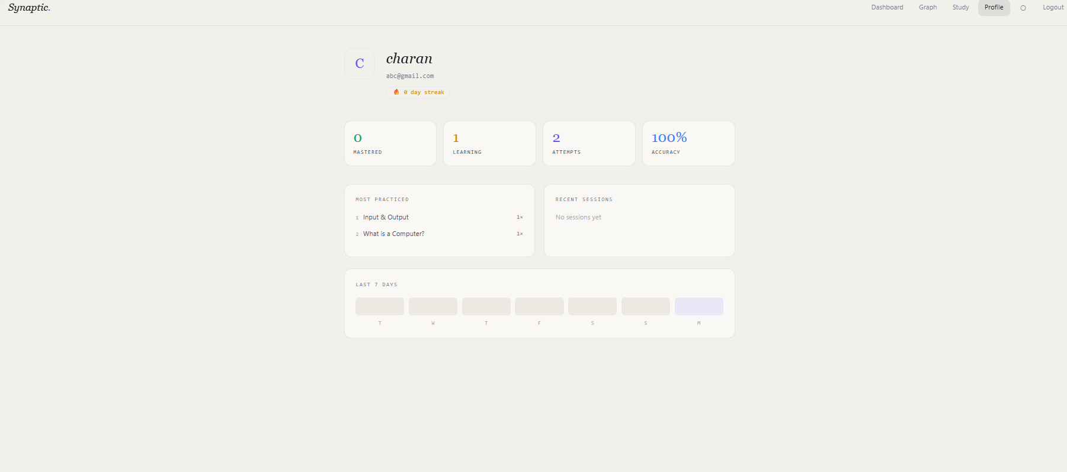

User Profile
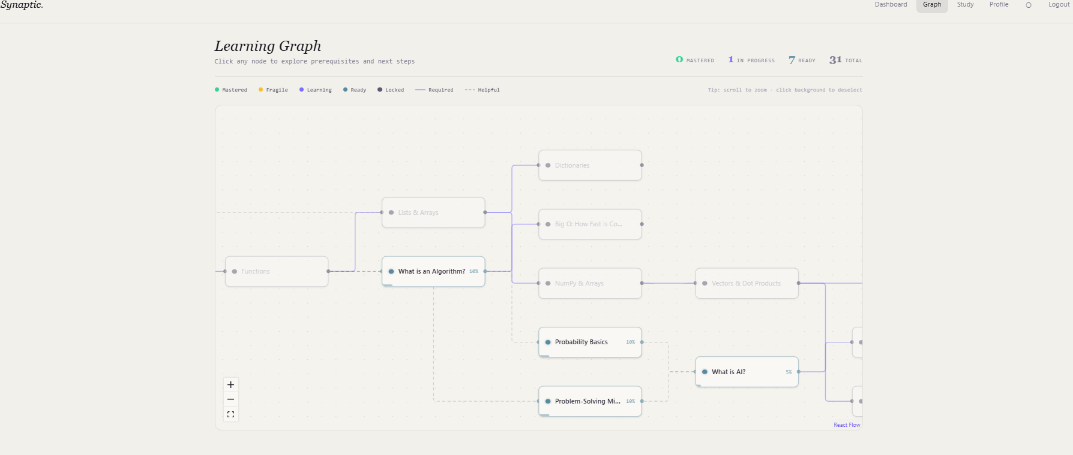
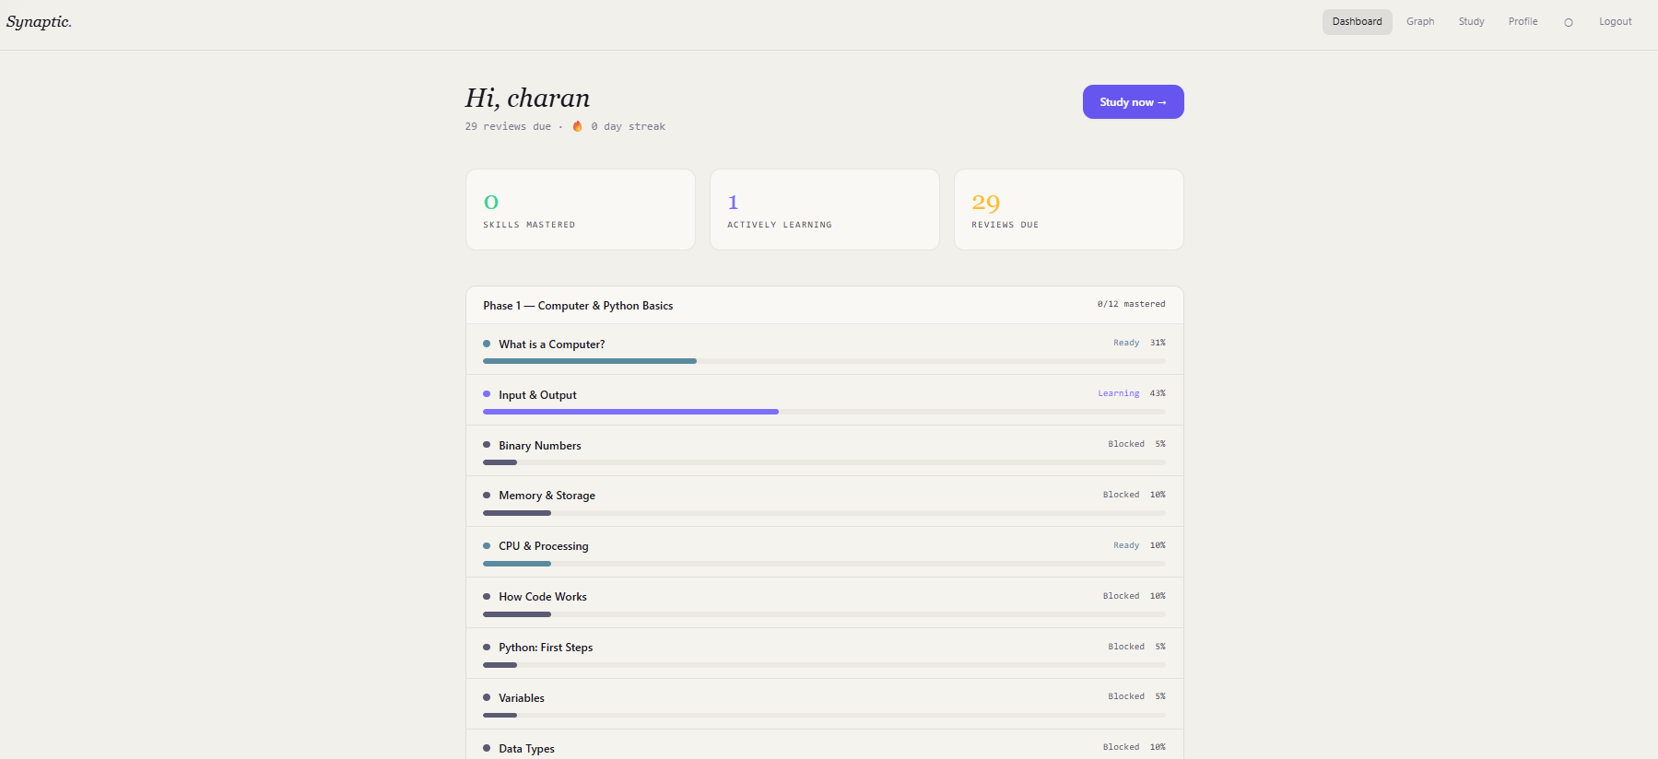

User Dashboard

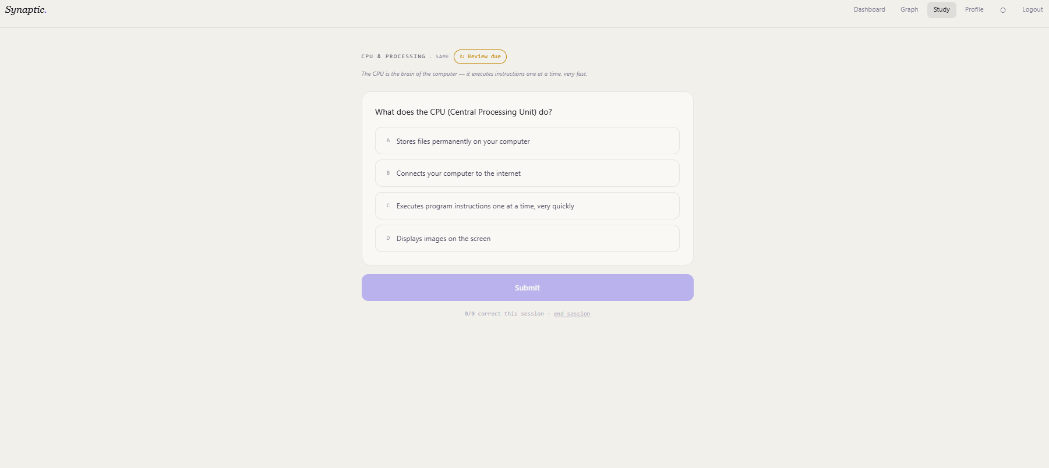

Learning Page

Learning Page

CONCLUSION AND FUTURE ENHANCEMENTS

7.1 Conclusion
The Synaptic – Adaptive Learning Platform successfully achieves its goal of providing a structured and interactive environment for learning Artificial Intelligence concepts. By integrating a phase-wise learning approach with quizzes and real-time feedback, the system enhances both user engagement and knowledge retention. The platform simplifies complex topics and presents them in an organized manner, making it suitable for beginners as well as intermediate learners.
The implementation of a user-friendly interface, combined with efficient backend processing and progress tracking, ensures a smooth and effective learning experience. Overall, the system demonstrates how modern web technologies can be utilized to create an engaging and scalable educational platform that supports continuous learning and skill development.

7.2 Future Enhancements
- Add explanation-based answers to capture real understanding.
- Build a reasoning evaluation module (rule-based → NLP/LLM upgrade).
- Combine correctness + reasoning + behaviour as input to BKT.
- Upgrade BKT to modern knowledge tracing (e.g., SAINT/DKT).
- Strengthen SM2 with adaptive scheduling based on performance patterns.
- Integrate behaviour analytics (time, retries, hesitation) for accuracy.
- Implement Bloom’s taxonomy tagging for cognitive-level control.
- Enhance adaptive engine using multi-metric scoring (not just know).
- Add practical evaluation modules (coding + real-time assessment).
- Build advanced dashboard + skill profile + personalized recommendations

BIBLIOGRAPHY

- Wozniak, P.A. (1990). Optimization of learning. Master's Thesis, University of Technology, Poznan, Poland. Foundation for SM-2 algorithm.
- Corbett, A.T. & Anderson, J.R. (1994). "Knowledge Tracing: Modelling the acquisition of procedural knowledge." User Modelling and User-Adapted Interaction, 4(4), 253–278.
- G. Latif, “Machine Learning in Higher Education: Students’ Performance Assessment Considering Online Activity Logs,” IEEE Access, vol. 11.
- R. Shahzad, “Multi-Agent System for Students Cognitive Assessment in E-Learning Environment,” IEEE Access, vol. 12
- S. G. Essa, T. Celik, and N. E. Human-Hendricks, “Personalized Adaptive Learning Technologies Based on Machine Learning Techniques to Identify Learning Styles: A Systematic Literature Review,” IEEE Access, 2023.

